Business Problem
Effective Inventory and Sales management are critical for optimizing profitability in the retail and wholesale industry. Companies need to ensure that they are not incurring losses due to inefficient pricing, poor inventory turnover or vendor dependency. The goal of this analysis is to :
- Identify underperforming brands that require promotional or pricing adjustments.
- Determine top vendors contributing to the sales and gross profit.
- Analyze the impact of bulk purchasing on unit costs.
- Assess inventory turnover to reduce holding costs and improve efficiency.
- Investigate the profitability variance between high-performing and low-performing vendors.

Exploratory Data Analysis Insights
Summary Statistics-
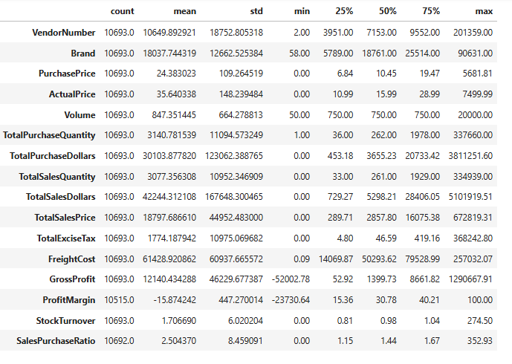

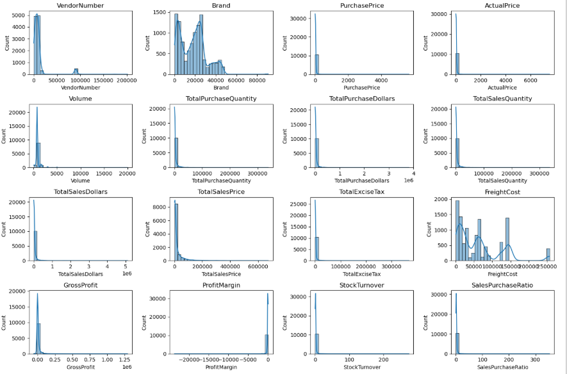

Negative & Zero Values:
- Gross Profit: Minimum value is -52002.78, indicating losses. Some products or transactions may be selling at a loss due to selling at high costs or selling at discounts lower than the purchase price.
- Profit Margin: Has a Minimum of -23730.64, which suggests the revenue is lower than total cost, leading to extreme profit margins.
- Total Sales Quantity & Sales Dollars: some products show zero sales indicating that they were purchased but never sold. These could be slow moving or obsolete stock, leading to inventory inefficiencies.

Outliers Indicated by High Standard Deviations:
- Purchase & Actual Prices: The max values (5681.81,7499.99) are significantly higher than the mean (24.38,35.64) indicating potential premium products.
- Freight Cost: Huge variation, from 0.09 to 257032.07, suggests logistics inefficiencies or bulk shipments.
- Stock Turnover: Ranges from 0 to 274.5, implying some products sell extremely fast while others remain in stock indefinitely. Value more than 1 indicates that sales for a product exceed the purchased quantity due to older stock fulfilling orders.

Data Filtering-
To enhance the reliability of insights, we removed inconsistent data points where:
- Gross Profit <= 0 (to exclude transactions leading to losses).
- Profit Margin <= 0 (to ensure analysis focusses on profitable transactions).
- Total Sales Quantity = 0 (To eliminate inventory that was never sold).

Correlation Insights –
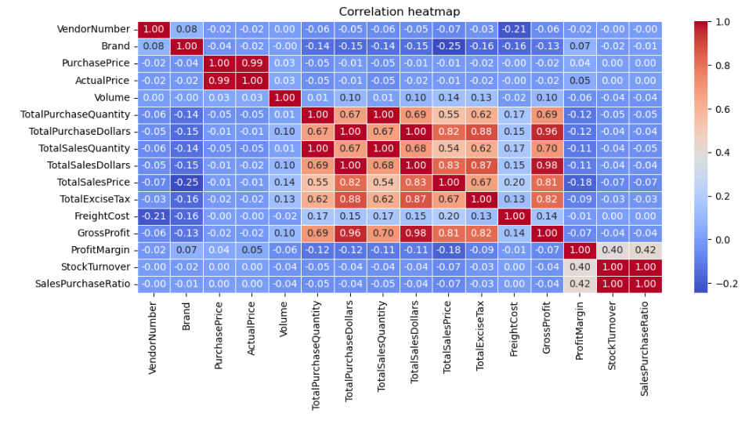
- PurchasePrice vs TotalSalesDollars & GrossProfit: Weak correlations (-0.01, -0.02) indicating that price variations do not significantly impact sales revenue or profit.
- Total Purchase Quantity vs Total Sales Quantity: Strong correlations (0.999) confirming efficient inventory turnover.
- Profit Margin vs Total Sales price: Negative correlation (-0.179) suggests that increasing sales price may lead to reduced margins, possibly due to competitive pricing pressures.
- Stock Turnover vs Gross Profit & Profit Margin: Weak negative correlations
(-0.038, -0.055) indicating that faster stock turnover does not necessarily equate to higher profitability.

Research Questions and Key Findings-
  - Brands for Promotional or Pricing Adjustments

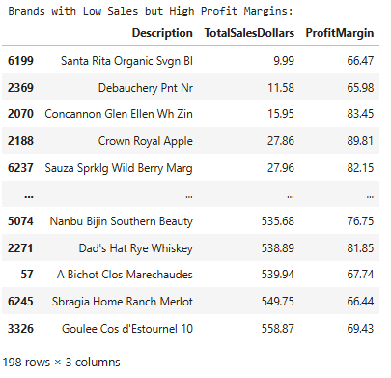

198 brands exhibit lower sales but higher profit margins, which could benefit from targeted marketing, promotions, or price optimizations to increase volume without compromising profitability.

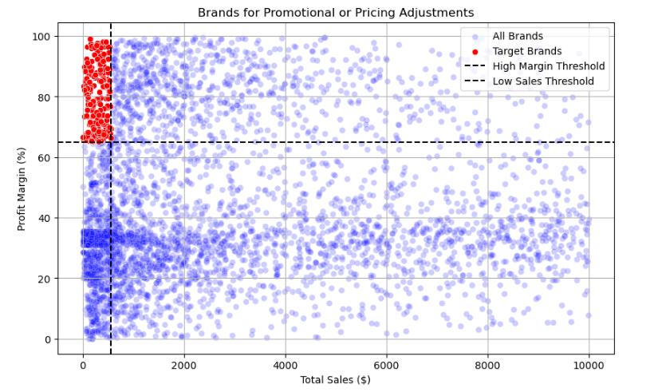
  - Top Vendors by Sales and Purchase Contribution
The top 10 vendors contribute 65.69% of total purchases, while the remaining vendors contribute only 34.31%. This over-reliance on only few vendors may lead to risks such as supply chain disruptions, indicating a need for diversification.
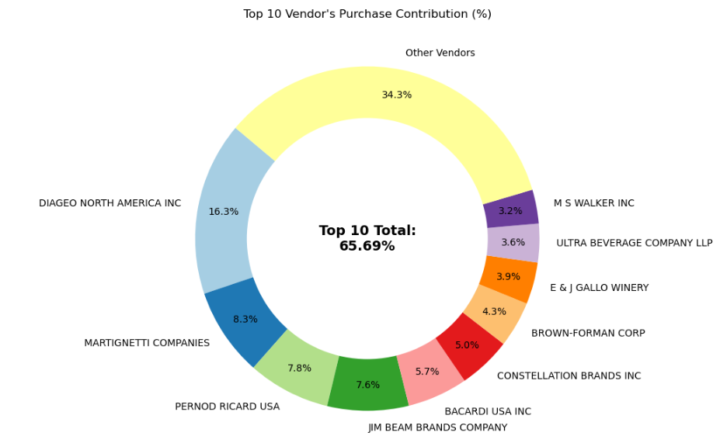

  - Impact of Bulk Purchasing on Cost Savings
Vendors buying in large quantities receive 72% lower unit cost ($10.78 per unit vs. higher unit costs in smaller orders).
Bulk pricing strategies encourage large orders, increasing total sales while maintaining the profitability.

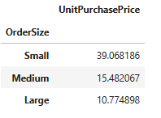

  - Identifying Vendors with Low Inventory turnover

Total Unsold Inventory Capital: $2.71M
Slow-moving inventory increases storage costs, reduces cash flow efficiency and effects overall profitability.
Identifying vendors with low inventory turnover enables better stock management, minimizing financial strain.
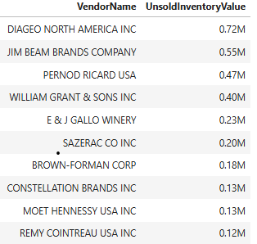
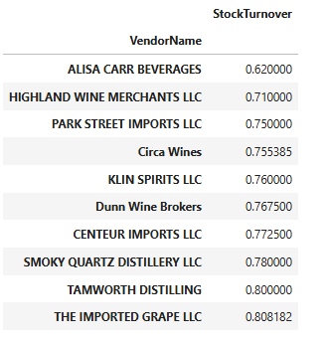

  - Profit Margin Comparison: High vs Low-Performing Vendors

Top Vendors Profit Margin (95% CI): (30.77, 31.65) Mean: 31.21
Low Vendors Profit Margin (95% CI): (37.30, 38.27) Mean: 37.78
Low-Performing Vendors maintain higher margins but struggle with sales volumes, indicating potential pricing inefficiencies or market reach issues.

Actionable Insights:
- Top-Performing Vendors: Optimize profitability by adjusting pricing, reducing operational costs, or offering bundled promotions.
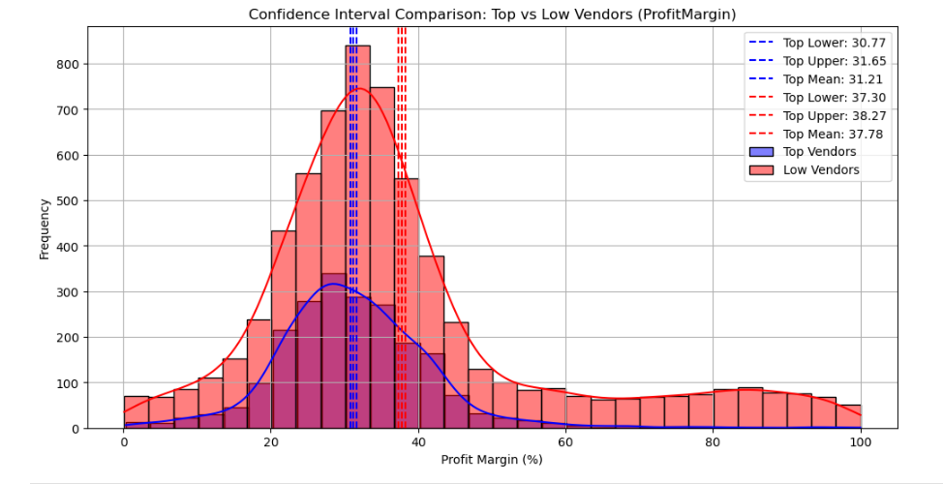
- Low-Performing Vendors: Improve marketing efforts, optimize pricing strategies and enhance distribution networks.

  - Statistical Validation of Profit Margin Differences

Hypothesis Testing:

- Ho (Null Hypothesis): There is no significant difference in the profit margins of top-performing and low-performing vendors.
- H1 (Alternative Hypothesis): A significant difference exists in profit margins of top-performing and low-performing vendors.

Result: The Null hypothesis is rejected, confirming that the two groups operate under distinctly different profitability models.

Implication: High margin vendors may benefit from better pricing strategies, while top-selling vendors could focus on cost efficiency.
Dashboard Insights

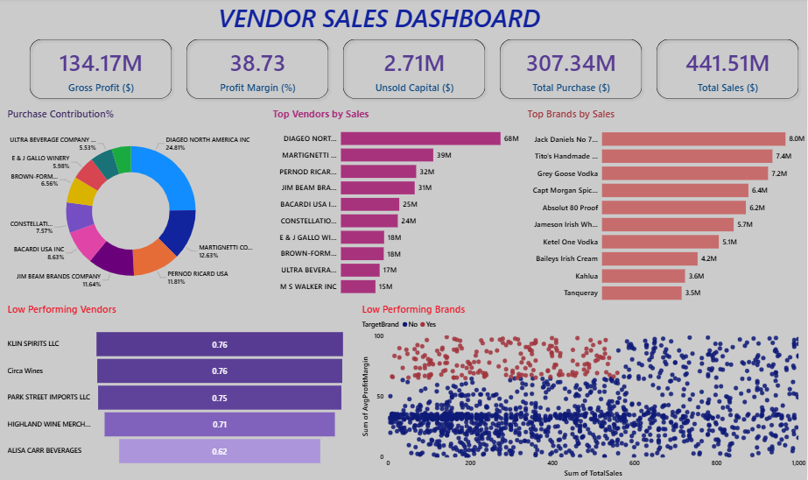

- Overall Business Performance –
The business generated a total sales revenue of $441.51M with a gross profit of $134.17M, resulting in a profit margin of 38.73%. However, a significant $2.71M is tied up in unsold inventory, indicating potential inefficiencies in inventory management.
- Vendor Contribution –
Sales are heavily concentrated among a few key vendors, with Diageo North America Inc. leading at $68M, followed by Martignetti and Pernod Ricard. This indicates a high dependency on top vendors, which could pose a risk if supplier relationships change.
- Brand Performance –
Premium brands such as Jack Daniel’s, Tito’s Handmade Vodka, and Grey Goose Vodka dominate sales, each contributing over $7M. This suggests that well-established brands drive a significant portion of revenue.
- Purchase Distribution –
Purchase contribution is fairly distributed across vendors, but a few vendors like Diageo North America Inc. and Martignetti Co. account for a large share, indicating concentrated procurement patterns.
- Low Performing Vendors –
Vendors such as KLIN Spirits LLC, Circa Wines, and Park Street Imports LLC show consistently low performance scores (below 0.8), indicating poor sales efficiency and potential underperformance.

- Low Performing Brands –
The scatter analysis shows a cluster of brands with low sales but relatively high profit margins, suggesting inconsistent demand patterns. Some brands fail to convert inventory into sales effectively.

- Inventory & Efficiency Insight -
The presence of unsold capital ($2.71M) combined with low-performing vendors and brands indicates inefficiencies in inventory planning and demand forecasting

Final Recommendations-
- Re-evaluate pricing for low sales, high-margin brands to boost sales volume without sacrificing profitability.
- Diversify vendor partnerships to reduce dependency on a few suppliers and mitigate supply chain risks.
- Leverage bulk purchasing advantages to maintain competitive pricing while optimizing inventory management.
- Optimize slow-moving inventory by adjusting purchase quantities, launching clearance sales or revising storage strategies.
- Enhance marketing and distribution strategies for low-performing vendors to drive higher sales volumes without compromising profit margins.
- By implementing these recommendations, company can achieve sustainable profitability, mitigate risks and enhance overall operational efficiency.

